Morning Worship
Greetings and Announcements

Approach to God
* Silent Prayer
* Call to Worship: Psalm 75:1
* Prayer of Adoration and Invocation
* Hymn: # 22
Reading of God’s Law
Confession of Sin
Words of Assurance
*Hymn: #460
*Confession of Faith: The Apostles’ Creed (Pg. 845)
Word from God
Hymn: # 590
Prayer for Illumination
Scripture Reading: 1 Peter 2:18-25
Congregational response: Amen
Sermon: Sojourners and Exiles, Follow Jesus’ Example
Prayer of Application
Our Response to God
Offering & Hymn: # 599
Prayer of Thanksgiving & Pastoral Prayer
Doxology: # 735 Gloria Patri
* Benediction
* Silent Prayer
* Those who are able are asked to stand.
Evening Worship
Gathering Hymn: # 310
Congregational Prayer

Approach to God
* Call to Worship: Psalm 89:49-52
* Prayer of Adoration and Invocation
* Hymn: # 3
Hymn: # 705
Word from God
Prayer for Illumination
Scripture Reading: John 13:21-30
Congregational response: Amen
Sermon: Learning from a Betrayer
Prayer of Application
Our Response to God
Sacrament of the Lord’s Supper†
(The Lord’s Prayer in Unison Afterwards)
* Hymn: # 253
* Benediction
*Silent Prayer

* Those who are able are asked to stand.
† Wine is in the inner rings of the tray; grape juice is in the outer ring.

“May I Come to the Lord’s Table?”
Each Lord’s Day, the Lord’s Supper is observed here at Trinity Presbyterian Church (ARP). If you are a visitor, please consider the following questions:
- Have you been baptized and professed your Christian faith in a Protestant church, and are thereby a communicant member of such a church? Are you in good standing with your church?
- Do you continue to place your faith in Jesus Christ for the forgiveness of your sins as your single hope for eternal life?
- Do you, in gratitude for your salvation and with the help of the Holy Spirit, rededicate yourself to God in a life of service in obedience to his Word?
The Bible calls all obedient servants of His to join with Him at this Supper in a spirit of joy and gratefulness. If you answered the above questions affirmatively, we welcome you to the Lord’s Table. The Bible also issues a solemn warning to the unrepentant and disobedient that, lest they incur further judgment upon themselves, they should refrain from participating.
If you have any questions about your participation here, or about any other spiritual matter, please speak to one of the elders or to the pastor.
Prayer Items:
- This week we will pray for the Nymann family.
- Pray that the love of our Triune God would shape our homes.
- Pray God would call men into gospel ministry in our Presbytery.
- Pray for the teenagers of our church. Pray they grow in love for Christ.
- The Canadian Presbytery prayer focus for this week is Riverside ARP Church in Cambridge, ON.

“The evil hate the good, because it condemns their evil; they try to make themselves despise it because it makes them despise themselves….If, my dear friend, you are a thorough-going Christian, you must not expect to escape scorn, because your life is a standing protest against the lives of others.”
- Charles Spurgeon

Announcements

Receiving new members and baptism: On June 20th, Adam and Ariel Gittleman, and their children will be received as members of our church. This service will be held outside at David and Katy VanKesteren's property. This will allow us the maximum number of visitors. Their children, Easton and Patrick will also receive the sacrament of baptism. We give God praise for his grace in this family. Pray they would grow to love God more and more.

Wednesday Evening Prayer: Our regular prayer meeting via Zoom will take place this Wednesday beginning at 7:30 p.m.

Worship Service Guidelines: To comply with social distancing guidelines, we encourage our church family to practice these guidelines:

• Bring your own Bibles.
• Hymn books will be provided, but please keep them for your own use week by week to avoid required cleaning/sanitizing.
• During the worship service, families are to sit together and keep a distance of six feet from other families.
• Parents, prepare your children not to run on the gym stage, climb the bleachers, or try to open locked doors (the alarm will sound).
• Wear a mask.

Pastor-Teacher: Rev. Henry Bartsch (519) 354-3240
Associate Minister: Rev. Jonathan Cowan (226) 580-2671 (cell)
Ruling Elders: Mr. John Moerman (519) 674-2511
Mr. Henry VanTil (519) 676-1143
Mr. John Nymann. (519) 991-6289
Deacon: Mr. John Timmermans

Welcome to
TRINITY
ASSOCIATE REFORMED PRESBYTERIAN CHURCH

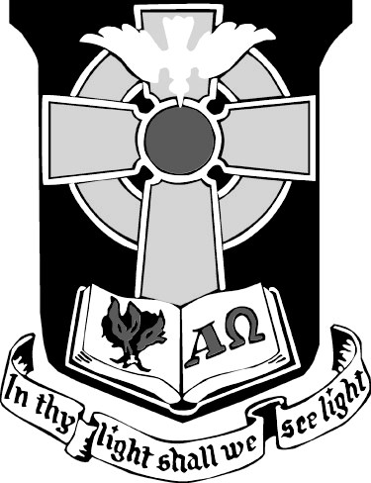
Meeting Sundays at 10:00 a.m. and 5:00 p.m.
Chatham Christian Schools, 475 Keil Drive South
Chatham, Ontario
SUNDAY, JUNE 13, 2021
If you are visiting with us today and have any questions about our church or building facility, you are welcome to speak with the greeters; they are available to help you in any way they can.
Today’s greeters: Harangozo family
Next week’s greeters: Luimes family
Church website: trinityarp.org

